Submission to the Journal Of Biomedical Engineering Systems and Technologies for Low- and Middle-Income Countries (BEST-LMIC)

Instructions to authors
Use this template, replacing all parts highlighted in yellow by your own text (remove the highlighting). For guidance see the Recommendations for the Conduct, Reporting, Editing, and Publication of Scholarly work in Medical Journals.
http://www.icmje.org/recommendations

Before preparing manuscript for submission, read carefully the submission guidance of the journal:

Select 3-6 keywords

Each bibliographic reference in the text should be identified by a number in superscript¹ in order of appearance and be listed in numerical order at the end. That is, the piece of literature that is referred to first in the text should also be the first one in the list of references at the end, regardless of the alphabetic order. Word’s Insert Cross-reference function (under the References pull-down menu / Captions) can be used to insert a semi-automatically updating reference in the text. Select Reference type: Numbered item, Insert reference to: Paragraph number, clear the box Insert as hyperlink. To refer to authors by name, use ‘according to Author et al.² …’. Software for referencing such as EndNote Basic, Mendeley (free), RefWorks, Zotero (Select the "Vancouver (Superscript)" style template) can be used To refer to more than one piece of literature in the same place, list the references with commas between them ^{1,2}.

Apply the referencing style as used by the U.S. National Library for Medicine (NLM) for examples, see http://www.nlm.nih.gov/bsd/uniform_requirements.html

Abbreviations for journals can be found e.g. at
http://www.ncbi.nlm.nih.gov/nlmcatalog/journals
http://www.efm.leeds.ac.uk/~mark/ISIabbr/

This first page will not be included in the double-blind review process – reviewers will not know the identity of the author(s) and the author(s) will not know the identities of the reviewer(s). The author information will be moved to the final camera-ready submission.

Author information page
This page has to be submitted in a separate file which is clearly named Author Information for the manuscript on …..(title of the manuscript).

Title (style title)
First Author ^{1,}*, Second Author ², Third Author ^{1,3}
¹ First Institution, City, Country
² Second Institution, City, Country
³ Third Institution, City, Country
*Corresponding author: First Author (email: name@domain)
Acknowledgements
To pertain anonymity, the acknowledgements section is included here and not in the manuscript file submitted for reviewing. In the final camera-ready version this shall be included at the end of the conclusion section as it appears in the published manuscripts on our platform, remember to acknowledge funding, project, persons other than the authors who contributed significantly, etc.

Authors' Contributions

To pertain anonymity, the Author's Contribution section is included here and not in the manuscript file submitted for reviewing. In the final camera-ready version this shall be included at the end of the acknowledgement section as it appears in the published manuscripts on our platform, remember to highlight the work that each author did in the carrying out of the study and development of this manuscript.

Declaration of Interests
To pertain anonymity, the Declaration of Interests section is included here and not in the manuscript file submitted for reviewing. In the final camera-ready version this shall be included at the end of the Author's Contribution section as it appears in the published manuscripts on our platform either remove the paragraph on conflicts of interest or state if an author was for example employed by an organization that was studied. A possible conflict of interest does not prevent the paper from being published, but it must be declared explicitly.
Title (style title)
(Author names will go here in the final paper - leave empty when submitting for reviewing)
(Author affiliations will go here in the final paper - leave empty when submitting for reviewing)

Abstract
Provide an abstract of up to 256 (headings included) words structured under the headings provided.
Background and Purpose: Summarize the Introduction section here and specify the paper’s purpose clearly.
Methods: Summarize the Methods and Materials section here.
Results: Summarize the main results from the Results section here.
Conclusions: Summarize the main conclusions from the Discussion section here.
Keywords: First keyword, Second keyword, Third keyword.

1 Introduction
Provide a context or background for the study (that is, the nature of the problem and its significance). State the specific purpose or research objective of the study or observation; the research objective is often more sharply focused when stated as a question. Both the main and secondary objectives should be clear. Provide only directly pertinent references, and do not include data or conclusions from the work being reported. (style Normal)

More text. (style Normal)
  - Subheading (style heading2)
Subheadings that signpost the presentation are encouraged, especially in the Results section. If subsections or sub-subsections are used, there must always be at least two of them within the higher level section in question.

More text. (style Normal)
    - Sub-subheading (style heading3)
Sub-subheadings are not recommended but can be used if needed for clarity. (style Normal)

More text. (style Normal)
    - Sub-subheading (style heading3)
Sub-subheadings are not recommended but can be used if needed for clarity. (style Normal)

More text. (style Normal)
  - Subheading (style heading2)
Subheadings that signpost the presentation are encouraged. (style Normal)
The use of figures and tables is encouraged. To insert a figure, first add a paragraph using the style image and then insert the figure (select Wrapping: In line with text). Then click the figure, select References -> Insert caption (Select Label: Figure) and enter the caption text. Then click the caption text and change the paragraph style to figurecaption. See the example below. A figure must always be explained in the text (Figure 1).
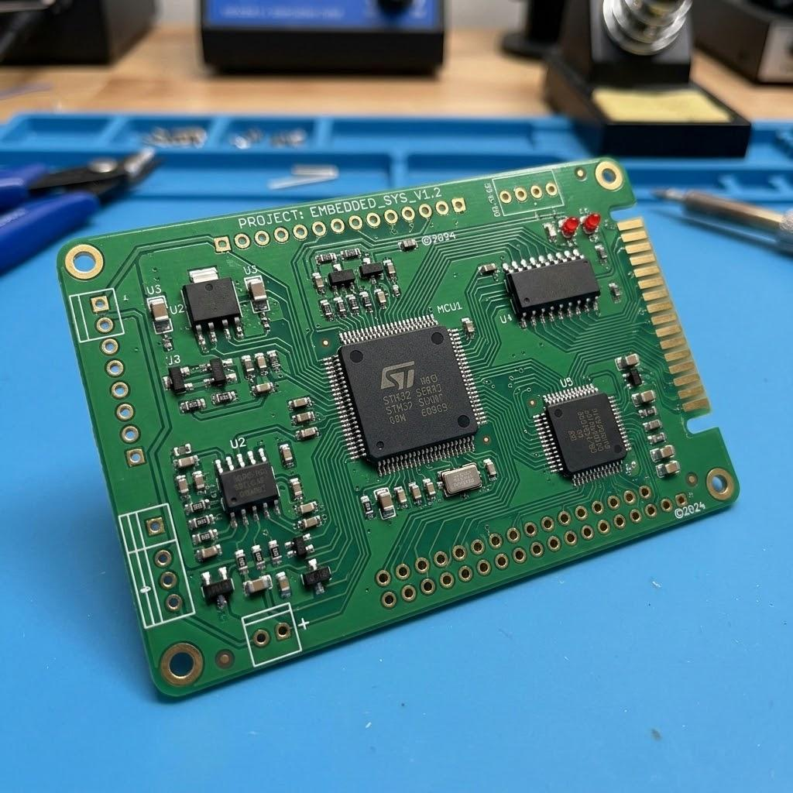
Figure 1. This is caption text.
The paragraph following a figure or table should be in the style Normal. A table must always be explained in the text (Table 1). It must also have a caption (above the table) in the style tablecaption. See the example below.
Table 1. This is a sample table caption.
Table heading | Table heading | Table heading
Table entry | Table entry | Table entry
Table entry | Table entry | Table entry

The paragraph following a figure or table should be in the style Normal. A short quotation citing a person or taken word-by-word from can be embedded in the normal text in quotation marks in italics, indicating the source after the quotation: “this is a quotation from B.A. Bauthor’’.² Longer quotations should be inserted as separate paragraphs in quotation marks as follows, indicating the source of the quotation:
“This is a verbatim quotation from what a person said.” (Interviewee 23)
The paragraph following a quotation should be in the style Normal.
- This is an example of a bulleted list. (style List Paragraph)
- This is an example of a bulleted list. (style List Paragraph)

2. Material and Methods
The Methods section should include only information that was available at the time the plan or protocol for the study was being written; all information obtained during the study belongs in the Results section. Identify the methods and procedures in sufficient detail to allow others to reproduce the results. Give references to established methods; provide references and brief descriptions for methods that have been published but are not well-known; describe new or substantially modified methods, give the reasons for using them, and evaluate their limitations.

If the research involved human subjects, you must include a clear statement of the ethical approvals by appropriate bodies and of the way the subjects’ free and informed consent was obtained.

Describe your selection of the observational or experimental participants clearly, including eligibility and exclusion criteria and a description of the source population.

If you used any equipment to collect data make sure to explicitly say which equipment was used and its model in brackets.

3. Results
Present your results in logical sequence in the text, tables, and illustrations, giving the main or most important findings first. Do not repeat all the data in the tables or illustrations in the text; emphasize or summarize only the most important observations. Extra or supplementary materials and technical detail can be placed in an appendix where they will be accessible but will not interrupt the flow of the text.

When data are summarized in the Results section, give numeric results not only as derivatives (for example, percentages) but also as the absolute numbers from which the derivatives were calculated, and specify the statistical methods used to analyze them. Restrict tables and figures to those needed to explain the argument of the paper and to assess supporting data. Use graphs as an alternative to tables with many entries; do not duplicate data in graphs and tables.

4. Discussion
Emphasize the new and important aspects of the study and the conclusions that follow from them in the context of the totality of the best available evidence. Do not repeat in detail data or other information given in the Introduction or the Results section. For experimental studies, it is useful to begin the discussion by briefly summarizing the main findings, then explore possible mechanisms or explanations for these findings, compare and contrast the results with other relevant studies, state the limitations of the study, and explore the implications of the findings for future research and for clinical practice.

5. Conclusion (and Recommendations)
Link the conclusions with the goals of the study but avoid unqualified statements and conclusions not adequately supported by the data. In particular, avoid making statements on economic benefits and costs unless the manuscript includes the appropriate economic data and analyses. Avoid claiming priority or alluding to work that has not been completed. State new hypotheses when warranted, but label them clearly as such.

References
- Author A, Bauthor BA, Cauthor C. Title of journal article: Subtitle of journal article. Journal Abbreviation. year;vol(number):firstpage-lastpage. Available from: http://www.domain/page
- Bauthor BA. Title of Book: Subtitle of Book. Publisher-hometown: Publisher; year.
- Cauthor C, Author A. Title of conference paper. In: Editor E, Feditor F, editors. Title of Proceedings. Conference Name; conference-year month dates; City, Country. Publisher-hometown: Publisher; year. p. firstpage-lastpage.
- Website title [Internet]. Publisher-hometown: Publisher; [cited year month date]. Available from: http://www.domain/page

